IN1004 Mathematics for Computing
3. Functions

3.1 Introduction

The concept of a function is very important in mathematics. It is also something that many of you will have already used, possibly without realising it. For example, if we talk about sine(θ) – we are taking an angle and returning the sine of the angle. One definition of a sine is that it represents the ratio between opposite side and the hypotenuse in a triangle. Thinking about this in terms of set theory, we are expressing a relation between an angle expressed in degrees (or indeed in radians) and a real number -1≤ x ≤1. Functions also appear in programming languages – hence one of the reasons for studying them (and indeed, set theory).

Definition: For non-empty sets, A, B, a function, or mapping, f, from A to B, denoted f: A → B, is a relation from A to B in which every element of A appears exactly once as the first component of an ordered pair in a relation.

Despite its possibly obscure definition, functions are something with which we are all very familiar.

Examples

If we consider the set N of natural numbers, then square : N → N is a function mapping numbers in the familiar way. Another way of writing a function is: f(a) = b when (a,b) is an ordered pair in the function f. Thus square(a)=b contains the following ordered pairs {(0,0),(1,1),(2,4),(3,9),(4,16),(5,25)…}. We may also express this function in more familiar notation: y = x² or f(x)= x². Using the notation y = x², x is called an independent variable and y is a dependent variable. Another way of looking at the function definition in the context of square, is that every natural number n has exactly one square.

Definitions

For the function f: A → B, A is called the domain of f and B the co-domain of f.

If we think about A and B in this definition, then A represents all possible values we can give the function and all possible results of the function are elements of B. The set of possible values f(a), where a ∈ A is a subset of B called the range (or image) of f. We will also talk about the image of a under f for individual elements, a ∈ A.

Put very simply, a function is something that accepts one number as an input, performs a pre-defined mathematical calculation on that number, and produces a result. This makes the function definition much more akin to a function in a computer program.

3.2 Functions and Relations

One obvious question that arises from our study of functions is: in what way do they differ from relations? Consider a function f:N → N. this is also a relation. For example, if we consider f(x)= x² defined over N, the set of natural numbers, then this is also a relation on N as it consists of ordered pairs defined on N x N. The next questions then are:
- Are all functions also relations?
- Are all relations also functions?

The answer to question 1 is a simple “yes”, but the answer to question 2 is “no”. The reason lies in the definition (repeated from above):

For non-empty sets, A, B, a function, or mapping, f, from A to B, denoted f: A → B, is a relation from A to B in which every element of A appears exactly once as the first component of a ordered pair in a relation.

The crucial part is that every element of A appears exactly once – this is not necessarily the case for a relation from A to B.

Square-root is somewhat problematic. If we define it as a function f: N → N, then we discover that it is not closed under N. If we define it as a function f: R → R then we run into more problems – two of them. For certain cases of the output appears not to be in the co-domain, e.g. the square root of -1 (this problem can be overcome by making the co-domain C). The other problem is that for values of R in the domain, there are two values in the co-domain (e.g. the square root of 4 is 2, but also -2). Square-root in these circumstances is not a function. We could of course restrict square root to make it f: R⁺ → R⁺. This would force the positive root of the number.

3.3 Function Composition

Consider functions f: A → B and g: B → C i.e. the co-domain of f is the domain of g (we may also say, the output of function f is used as input for function g). Then we may define a new function from A to C, called the composition of f and g written g ° f as follows:
(g ° f) (a) ≡ g(f(a))

3.4 Special Types of Functions

3.4.1 One-to-One Functions

A function f: A → B is called a one-to-one, or injective function, if each element of B appears at most once as the image of an element of A. The function square, defined over the set of natural numbers N is one-to-one, but when square is defined over the set Z (the set of integers) – it is not one-to-one. Why?

Another way of looking at one-to-one functions is to say that every element in the domain maps onto a different element in the co-domain – in another words, using an arrow diagram, every element in the co-domain will have at most one arrow pointing at it.

Example

The function f: N → N, where f(n) = n+1 is injective:
4
3
2
1
0
4
3
2
1
0

Let f : A → B and g: B → C be function mappings. Then if both f and g are injective (one-to-one) then so is g ° f.

3.4.2 Onto Functions

A function f: A → B is called onto, or surjective, if f(A)=B, i.e. for all b∈B there is at least one a∈A with f(a)=b, the range is the co-domain.

In terms of arrow diagrams, this means that with an onto function, every element that appears in the co-domain has at least one arrow pointing at it.

The function f: R → R defined by f(x) = x³ is an onto function. (Note that the function f: R → R defined by f(x) = x² is not an onto function.)

A function that is both one-to-one and onto is called bijective.

3.4.3 Partial Functions

For any given function f: A → B, if there are elements in the domain (A) that do not map onto any values in the co-domain (B), then that function is called a partial function. One example might be square root defined over the domain Z. The function is partial because square-root is not defined for all Z<0 over set R. (Those people who have been introduced to complex numbers will know that it is defined over set C.) The function is therefore partial (there are some values of Z for which it is not defined). A function f : A→B is total if f is defined on all values of A. That is, a total function, is just a function.

3.5 Inverse Functions

A function f: A→ B takes x∈A and does something to it, namely it produces f(x)∈B. Sometimes we can find a function g which “undoes” what f does. We call this an inverse function. One well-known example from elementary Mathematics is sine and arcsine (also called sin⁻¹).

Aside: If we have a function f: A → B that, for any value of A it is easy to generate B, and given B, it is almost impossible to apply the inverse function f⁻¹ to re-create A then we have a useful method of encryption (passwords are often stored using a function of this type).

3.6 Some Mathematical Functions

3.6.1 Floor and Ceiling Functions

If x is a real number, then x lies between two integers called the floor and ceiling of x.
⎣x⎦ is called the floor of x and denotes the greatest integer that does not exceed x.
⎡x⎤ denotes the ceiling of x and is the least integer that is not less than x.

Examples
⎣2.718⎦ = 2
⎣-8.5⎦ = -9
⎡-8.5⎤ = -8
⎡7.01⎤ = 8

3.6.2 Integer and Absolute Value Functions

If x is any real number, the integer part of x, usually written INT(x), converts x into an integer by deleting (truncating) the fractional part of the number. The absolute value of x is defined as the greater of x or –x it is usually denoted ABS(x) or it is sometimes written | x |.

Examples

INT(3.4) = 3
INT(-4.5)= -4
ABS(5.2) = |5.2| = 5.2
ABS(-5.2) = |-5.2| = 5.2

3.6.3 Modular Arithmetic

In modular arithmetic counting is circular, once a maximum value is reached, the next count is back to 0. Let k be any integer and let M be a positive integer, then k (mod M) is the modulus of k with respect to M. When k is positive this corresponds to the integer remainder of k divided by M.
Examples

25 (mod 7) = 4
25 (mod 5) = 0
3 (mod 8) = 3

Observe the result of repeatedly adding 3 then using modular 10 arithmetic
0 + 3 ≡ 3
3 + 3 ≡ 6
6 + 3 ≡ 9
9 + 3 ≡ 2
2 + 3 ≡ 5
5 + 3 ≡ 8
8 + 3 ≡ 1
1 + 3 ≡ 4
4 + 3 ≡ 7
7 + 3 ≡ 0

We have obtained a permutation of all numbers between 0 and 9 – this forms the basis for random number generators, modular arithmetic is also used in hash functions (covered in a Computer Science Year 2 module).

Notice that with circular arithmetic, the modulus does not correspond to remained. With module 7 arithmetic
0 - 3 = 4
4 - 3 = 1
1- 3 = 5
-25 mod 7 = 3

3.7 Summation

It is often useful to write an expression describing adding up a sequence of number.

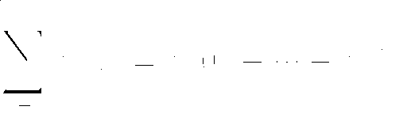

For example:

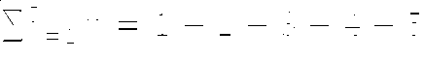

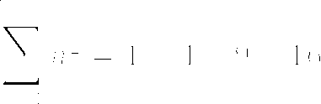

3.8 The Growth of Functions and Recursion

3.8.1 Graphs of Functions and Growth of Functions

In Computer Science, it is important to study algorithms and their growth when they process more and more data. In order to examine this, we will look at some common functions and their graphs. We will start off with the function y =x (or more generally y=mx +c).

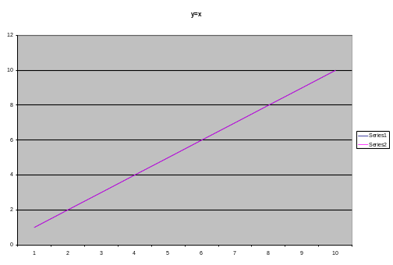

The graph above shows the function y=x, as we can see, it is a straight line and hence is called a linear function. We also note that as y grows, x grows exactly in proportion to y. It is possible to vary the gradient of the line using the parameter m and the point at which it crosses the y axis using c.

Next, we consider y = x².
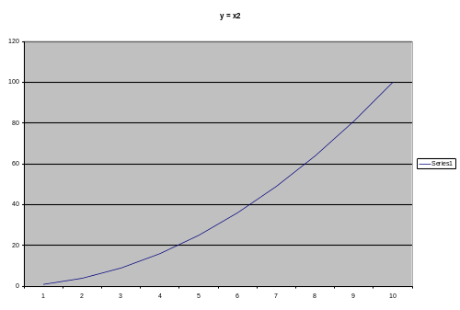

Here we see that y grows faster than x, giving us the characteristic curve of a quadratic equation.

Next y = x³
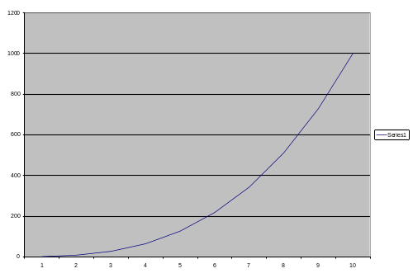

Similar to y = x² but with a steeper upward curve.

Now for y =2^{x} = 2 x 2 x … x 2 (2 multiplied by itself x times)
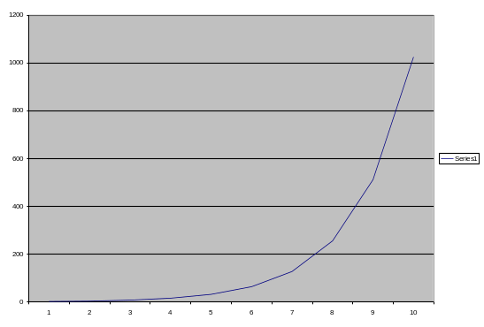

This, at first sight, looks similar to y = x³
But don’t be deceived, it starts slowly and then grows at a much more rapid rate than the cubic equation.
Now for y = x!
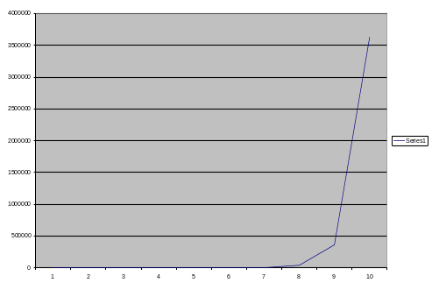

This function has massive growth. Now for two other functions:

y = log₂ x

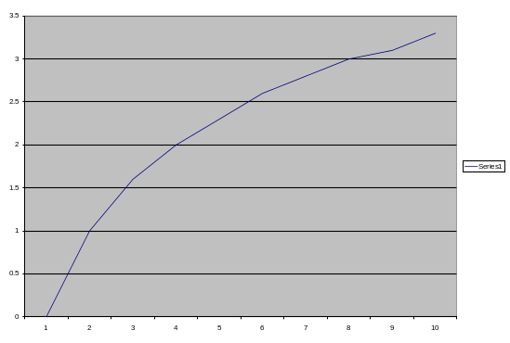
This graph appears to grow rapidly at first (though its scale is very different) and then level off.

Now let’s look at the data in tabular form:

n | log₂n | n | nlog₂n | n² | n³ | 2^{n} | n!
10 | 3.3 | 10 | 33 | 10² | 10³ | 10³ | 3.6 x10⁶
10² | 6.6 | 10² | 660 | 10⁴ | 10⁶ | 1.3 x 10³⁰ | 9.3 x 10⁵⁷
10³ | 10 | 10³ | 10,000 | 10⁶ | 10⁹ | - | -
10⁴ | 13 | 10⁴ | 130,000 | 10⁸ | 10¹² | - | -
10⁵ | 17 | 10⁵ | 1.7 x 10⁶ | 10¹⁰ | 10¹⁵ | - | -
10⁶ | 20 | 10⁶ | 2.0 x 10⁷ | 10¹² | 10¹⁸ | - | -

What does all this mean and why is it worthy of study?

When writing computer programs, despite the speed of modern computers, it is useful to know something about the algorithm that we are writing. For example, a program that processes a file of information, may probably take twice as long to process a file that is twice as long. In this case we say that the algorithm is linear, or is O(n).

How about an algorithm to sort numbers into ascending(or descending sequence)? Some algorithms require n² steps or O(n²) to perform this operation, however, the best sorting algorithms can perform this in O(n log n) which can make a significant difference in speed. If we come across an algorithm that requires n! steps or is O(n!) then we are in trouble. The whole point of studying what is known as algorithmic complexity is to ascertain that what we are trying to write a program to compute is actually computable in a realistic timescale. (This is called tractability.)

3.9 Recursively Defined Functions

The Well-Ordered Principle

The well-ordered principle states that any non-empty subset of Z⁺ contains a smallest element, i.e. that Z⁺ is well-ordered. This leads in two very interesting mathematical pathways. Firstly, sets that are well-ordered can be used to define recurrence relations in maths. As Computer Scientists we will be more interested in their use as recursive functions. Their second use is a very powerful technique in mathematics called proof by induction. Recursive definitions will be given now.

Recursive Definitions

A function is said to be recursively defined if the definition refers to itself. However in order for this to work, it must have two properties:
- There must be a base value, something for which the function does not refer to itself.
- Each time the function refers to itself, it must do so by a simplification that brings it closer to the base case.
Any recursive definition with these two properties is said to be well-formed. This recursive definition is very similar to a principle of programming called recursion. If you can understand recursive definitions, then you should be able to understand recursion.

Definition of Factorial

It is sometimes useful to multiply sequences of integers together and indeed many students who have studied, for example probability theory, may already have encountered this (indeed we will study and use the factorial function later in this course).
n! = nx(n-1)x(n-2)…x3x2x1
Thus
10! = 10x9x8x7x6x5x4x3x2x1
In general
n! = n x (n-1)!
Notice that this much neater version defines the factorial function in terms of itself.

Accordingly the factorial function may be defined in the following way:
- 0! =1; and
- For n ≥ 0 (n+1)! = (n+1)(n!)

Definition of Fibonacci Numbers

The Fibonacci numbers may be defined recursively by:

- F₀ =0, F₁ =1; and
- F_{n} = F_{n-1} + F_{n-2}, for n ∈ Z⁺, with n≥2

3.10 Algorithms and Functions

An algorithm is a finite step-by-step list of well–defined instructions for solving some problem.

Example

Greatest Common Divisor

There is a well-known way of obtaining the greatest common divisor of two numbers. The greatest common divisor of two numbers is the largest number that exactly divides both numbers e.g. GCD(12,8) = 4. This may be defined recursively:

GCD(a,0) = a
GCD(a,b) = GCD(b, a (mod b))

Note that a (mod b) is the remainder when a is divided by b. It is far from obvious how this method works.

GCD(258,60) 258/60 = r 18
GCD(60,18) 60/18 = r 6
GCD(18,6) 18/6 = r 0
GCD(6,0) = 6

Optional Material – Please read only if you are unfamiliar with logarithms.

Indices and Exponential Functions

There are three laws for positive indices:
- a^{m} x a^{n} = a ^{m+n}
- a^{m} ÷ a^{n} = a ^{m-n}
- (a^{m})^{n} = a^{mn}
We can take this further to see if these laws also hold for any indices.

We note that 4 ^{½} = √4 = 2 and that: 4 ^{½} x 4 ^{½} = 4

Now consider 8 ^{2/3}. 8 ^{1/3} = 8, so
8 ^{2/3} = 8 ^{1/3} x 8 ^{1/3} = 2 x 2 = 4.
∴we must take 8 ^{2/3} to be the square of the cube root of 8, and in general a ^{m/n} must be taken to mean the m^{th} power of the n^{th} root of a.

Zero and Negative Indices

If we divide 2¹ ÷ 2¹ = 2⁰ this is consistent with the second law of indices, hence 2⁰ = 1. In general a⁰ = 1 (a ≠0).

To find what meaning must be given to 2⁻¹ we divide 2⁰ by 2¹, using the second law of indices:
2⁰ ÷ 2¹ = 2⁻¹
But 2⁰ ÷ 2¹ = 1 ÷ 2 = ½ therefore we must take 2⁻¹ to be ½.
In the same way
A^{–n} = 1/a^{n}

The exponential function f(x) = a^{x} is defined for all real numbers. Note that the exponential function f(x) = e^{x} is a special case. e^{x} is only really explicable with the introduction of say calculus or hyperbolic functions – neither of which feature in this course.

Logarithms

A logarithm is an index, hence if we say 2³ = 8 then we can also say log₂ 8 = 3. The number 2 is the base of the logarithm. In Computer Science, logs with number base 2 are important, in Maths, logs with number base e are important. Logs with base 10 are also important?

Two numbers can be multiplied by adding their logarithms and divided by subtracting them, e.g. 8 x 4 = 32
Log₂ 8 + log₂ 4 = log₂ 8 x 4

Examples

Log₁₀ 100 = 2 (because 10² = 100)
Log₁₀ 0.001 = -3 (because 10⁻³ = 0.001)

Using the examples above, what is the result of adding Log₁₀ 100 and Log₁₀ 0.001 ? This is 2 + (-3) = -1 So is this correct? Log₁₀ 0.1 = -1 which is what we would expect if we multiplied 100 by 0.001

Example

A fundamental operation in computing is search – for example searching through a data file for the existence of a particular entry. If we have 100 numbers all randomly arranged, then we would have to search through the entire list of numbers to be sure that the number wasn’t there. If the list of numbers is sorted, in say, ascending order, then we only need to search through the list until we find a number that is greater then the one we are searching for to know it isn’t in the list. By ordering the numbers we cut down the search (on average) by a factor of two. Thus for a list of 100 numbers:
- Search through an unordered list takes 100 lookups for an item not in the list.
- Search through an ordered list takes on average 50 lookups for an item not in the list.
- Search on an ordered list using a binary search will take a maximum of 7 lookups. Mathematically, this is ⎡log₂ 100⎤.
- Search using a method called hash addressing takes around 1 lookup.

Exponential and Logarithmic Functions

If we consider the exponential and logarithmic functions:
f(x) = b^{x} g(x) = log_{b} x

These functions are inverses of each other – i.e. if you rotate the axes for one you get the other.

Tutorial Exercises

- If U = N, A = {1,2,3,4} determine whether each of the following relations is also a function from A into A.
  - f ={(2,3),(1,4),(2,1),(3,2),(4,4)}
  - f= {(1,1),(2,2),(3,3),(4,4)}
  - f= {(1,2),(2,2),(4,2)}
  - f= {(1,3),(2,3),(3,3),(4,3)}
  - f={(1,2),(2,3),(3,4),(4,0)}

- For part i) and ii) in question 1 – draw these relations using arrow diagrams.

- For each of the following functions, state whether they are a) partial, b) total, c) one-to-one (injective) d) onto (surjective), e) bijective:
  - f(x) = x+1 defined on N. (note if it is defined on N this means that both domain and co-domain are N).
  - f(x) = x+1 defined on Z
  - f(x) = x² defined on N
  - f(x) = x² defined on Z
  - f(x) = x² defined on R
  - f(x) = x³ defined on Z
  - f(x) = x³ defined on R
  - f(x) = ³√x defined on Z
  - f(x) = ³√x defined on R
  - f(x) = 1/x defined on Z

- Let f be a function from {a,b,c,d} to {1,2,3} defined by f(a)=3, f(b)=2, f(c)=1 and f(d)=3. Is f an onto function? Would it be an onto function if the co-domain were {1,2,3,4}?

- Compute the following:
  - ⎣0.3⎦
  - ⎡-0.1⎤
  - ⎣-0.5⎦
  - INT(-0.1)
  - INT(-1.2)
  - ABS(-0.6)

- Evaluate the following:
  - 23 (mod 7)
  - 25 (mod 5)
  - -35 (mod 11)

- Evaluate the following using modulo M=13
  - 9+12
  - 1+4
  - 6+7

- Write Java code to enable you to calculate the answers to 5., 6. and 7.

- Consider the set of positive natural numbers N {1,2,3,…}. Define this set as a recursive function. (Hint: what is the base case? Think downwards, rather than upwards.)

- One method of generating the n^{th} Fibonacci number is to start at 0, 1 and then add these together to produce the next number in the sequence. Use this method to generate the first few numbers in the Fibonacci series. Now repeat this using the recursive definition – make a note of the number of steps required. Which method is shorter – the first (iterative) method or the recursive method?

- Write a Java method that when invoked with actual parameter n (and integer) will return the n^{th} Fibonacci number.

- The Ackermann function can be defined as follows:
    - A(0,n) = n+1, n≥0
    - A(m,0) = A(m-1,1), m>0
    - A(m,n) = A(m-1,A(m,n-1)),m,n >0

Use this definition to find A(1,3).

- Use GCD to find the greatest common divisor of
  - 21, 903
  - 85, 272
  - 133, 760

- Can you write a Java method to calculate the GCD of two integers?

- Consider the following geometric progressions: in each case create a recursive definition that will enable us to compute the nth term in the progression.
  - 2,10,50,250,…
  - 6,-18,54,-162,…
  - 1, 1/3, 1/9, 1/27
  - 7,14/5,28/25,56/125….

16. Give an expression for the summation of the cube of each number from 1 to 100.

17. Evaluate:
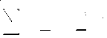

The Following Exercises Are Only Necessary For Anyone Unfamiliar With Logarithms

- Find the values of the following:
  - 9^{1/2}
  - 27^{1/3}
  - 27^{2/3}
  - 4^{1/2}
  - 4^{3/2}
  - 9^{5/2}
  - 8^{4/3}
  - 16^{3/4}

- What is the value of:
  - 7⁰
  - 3⁻¹
  - 2⁻³
  - (-6⁾⁻¹

- Simplify:
  - 8^{n} x 2^{2n} ÷ 4^{3n}
  - 3^{n+1} x 9^{n} ÷27^{2/3n}
  - 6^{1/2n} x 12^{n+1} x 27^{-1/2n} ÷ 32^{1/2n}

- Express the following statements in logarithmic notation:
  - 2⁴ = 16
  - 27 = 3³
  - 10⁶ = 1,000,000
  - 81 = (1/3)⁻⁴

- Express in index notation:
  - Log₂ 32 = 5
  - Log₃ 9 = 2
  - -2 = log₃ 1/9

- Evaluate:
  - Log₂ 64
  - Log₁₀ 100
  - Log ₁₀ 10⁷
  - Log₂₇ 3
  - Log_{2/3} 4/9

- Deduce that log _{c} a^{n} = n log_{c} a

Home Study
From Lipschutz and Lipsom. Read through section 3.1, 3.2 and 3.3 (for 3.3 omit example 3.4 and also the short section on permutations – though these come in useful at a later stage of the course). Look carefully through section 3.4.
Solved Problems – try exercise 3.1, 3.3 and 3.4, try 3.5 (ignore 3.6-3.9).
Try 3.15, 3.16, 3.17 ignore 3.18, try 3.19.

Learning Outcomes

- You should be able to understand what a function is and how it differs from a relation.
- You should understand the concept of domains and co-domains and be able to represent a function as an arrow diagram.
- You should be able to interpret functions represented as ordered pairs in sets.
- You should be able to understand the notion of function of function composition.
- You should be able to understand the idea of a one-to-one function, an onto function and a partial function.
- You should be able to compute the result of applying the floor, ceiling, integer and absolute functions.
- You should understand the notion of a remainder function and be able to use modular arithmetic.
- You should understand the three laws for positive indices and be able to carry out arithmetic using indices, including zero and negative indices.
- You should be able to understand and manipulate expressions using logarithms and the relationship between logarithms, indices and exponential functions.

